Week 3 Volunteer Analysis
Project Title: Campus Cultural Fest Operations Dashboard & Process Optimization System
Prepared By: Karthick Raja
Objective
The objective of this analysis is to evaluate volunteer workload distribution and task completion performance during the cultural fest.
This analysis helps determine whether volunteers were effectively utilized and whether operational responsibilities were distributed fairly.
Volunteer Workload Analysis
SQL Query Used,
SELECT
Volunteer_ID,
COUNT(*) AS Tasks_Assigned
FROM Task_Assignments
GROUP BY Volunteer_ID
ORDER BY Tasks_Assigned DESC;

Query Result
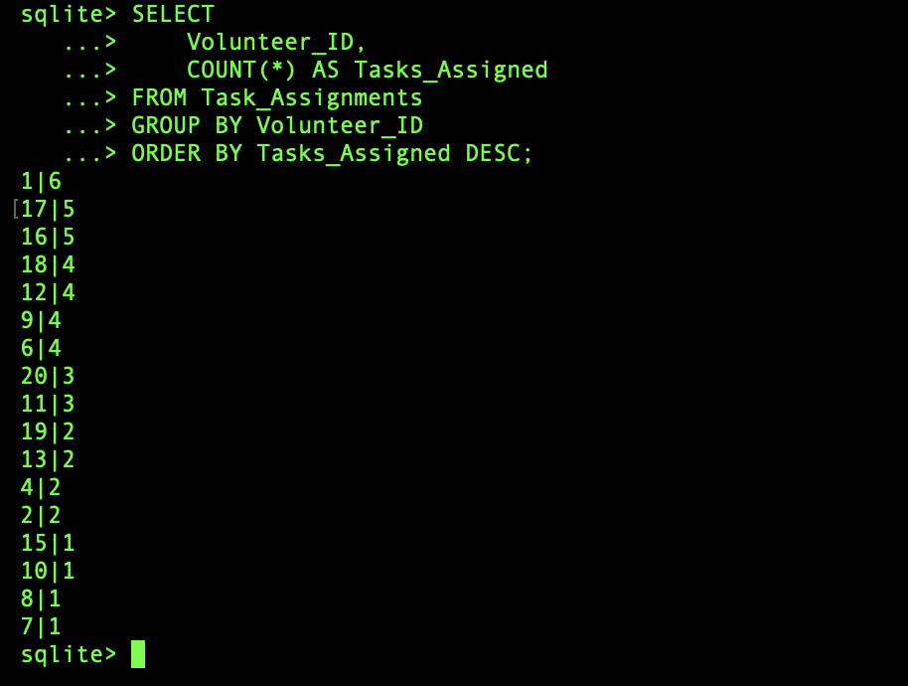
Used SQL Query,
SELECT
Task_Name,
COUNT(*) AS Frequency
FROM Task_Assignments
GROUP BY Task_Name
ORDER BY Frequency DESC;
Query Result
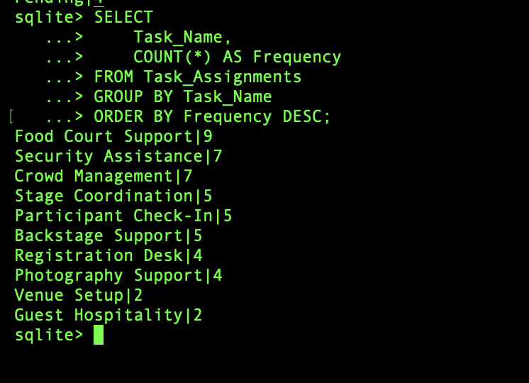
Volunteer Task Distribution
- The event had 20 Volunteers and 50 Assigned Tasks.
- Average Tasks per Volunteer is 50 ÷ 20 = 2.5 Tasks
Key Findings
Finding 1: Tasks Were Distributed Across Volunteers
The task allocation report shows that responsibilities were distributed among multiple volunteers rather than being assigned to a small group.
This reduced the risk of volunteer overload.
Finding 2: Balanced Workload
Most volunteers handled between 2 – 6 Tasks
This indicates relatively balanced workload allocation.
Finding 3: Volunteer Resources Were Fully Utilized
All operational activities such as:
- Registration Desk
- Crowd Management
- Stage Coordination
- Venue Setup
- Guest Hospitality
were assigned to volunteers.
This ensured event operations were adequately supported.
Task Completion Analysis
SQL Query Used,

SELECT
Task_Status,
COUNT(*)
FROM Task_Assignments
GROUP BY Task_Status;
Query Result
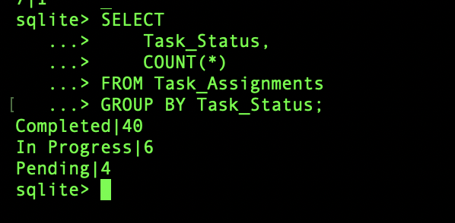
KPI Calculation
Task Completion Rate = Completed Tasks ÷ Total Tasks × 100
That is 70%.
Volunteer Performance Summary
Metric | Value
Total Volunteers | 20
Total Tasks Assigned | 50
Average Tasks per Volunteer | 2.5
Completed Tasks | 35
In Progress Tasks | 10
Pending Tasks | 5
Task Completion Rate | 70%
Visualization
Volunteer Task Distribution
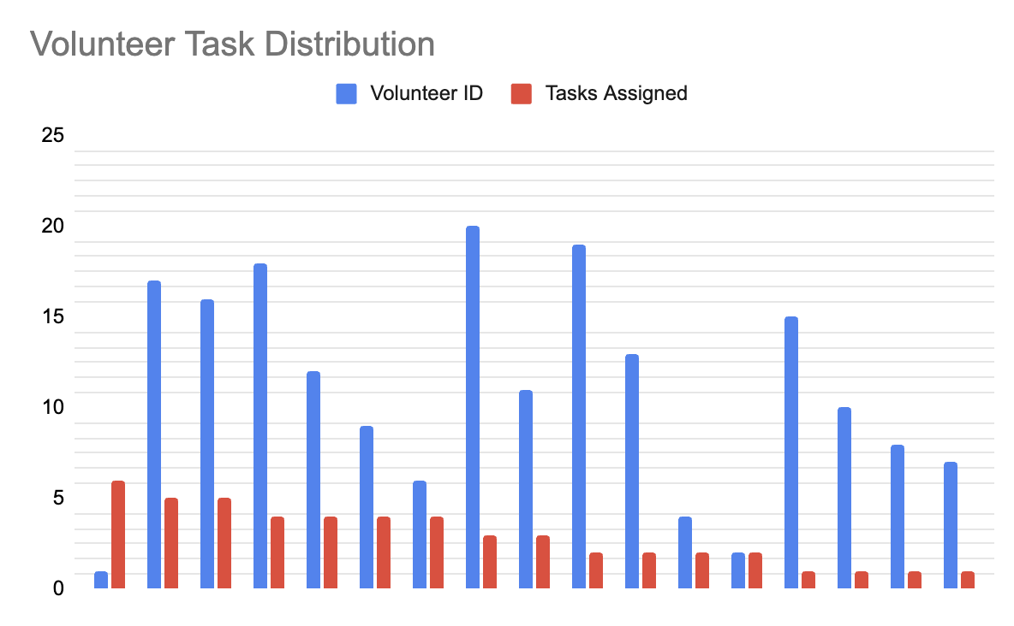

Task Status Distribution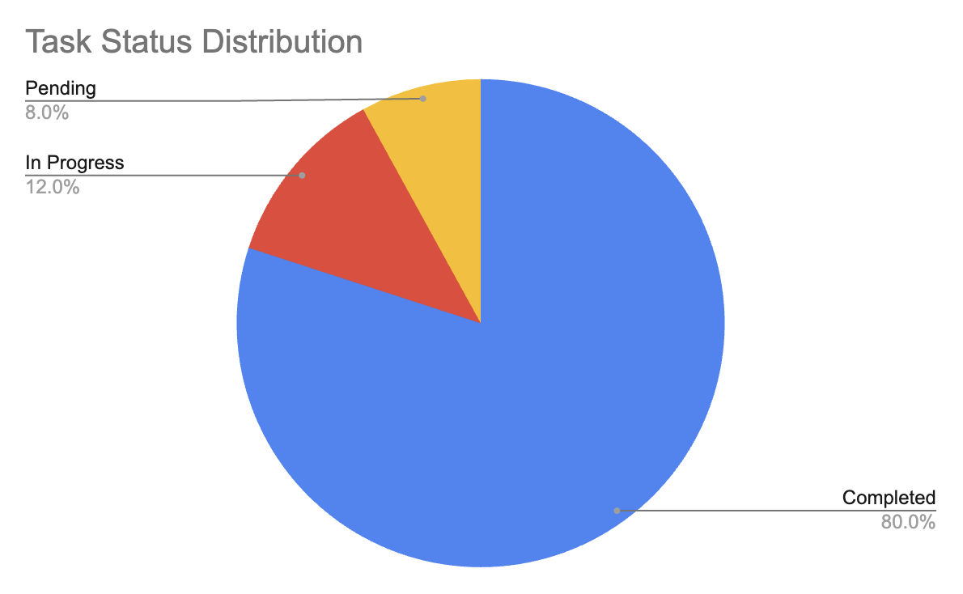
Business Impact
Volunteer management directly affects event operations.
Effective volunteer allocation helps:
- Reduce operational delays
- Improve participant experience
- Support crowd management
- Improve event execution
Monitoring volunteer utilization enables better resource planning for future cultural festivals.
Recommendations
Recommendation 1
Maintain balanced task allocation among volunteers to prevent workload concentration.
Recommendation 2
Provide task checklists to volunteers before event day. This can improve task completion rates.
Recommendation 3
Introduce shift-based scheduling for large-scale events to improve volunteer efficiency.
Conclusion
The volunteer analysis showed that operational tasks were distributed across 20 volunteers supporting the cultural fest. Workload distribution was generally balanced, with most volunteers handling between 2 and 6 tasks.
The analysis indicates that volunteer resources were effectively utilized to support registration, venue management, crowd control, and event coordination activities.

